**Get started on the next course**

Congratulations on completing Course 4 of the Google Cybersecurity Certificate:**Tools of the Trade: Linux and SQL**! In this part of the program, you learned about computing skills that will support your work as an analyst. First, you learned about operating systems. Then, you communicated with the Linux operating system through the Bash shell in order to complete security-related tasks. Finally, you performed SQL queries that returned information to support security-related decisions.

The Google Cybersecurity Certificate has eight courses:

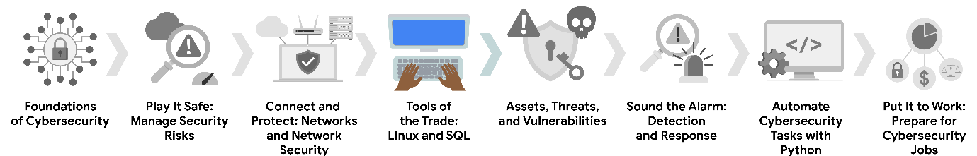

1. **Foundations of Cybersecurity** — Explore the cybersecurity profession, including significant events that led to the development of the cybersecurity field and its continued importance to organizational operations. Learn about entry-level cybersecurity roles and responsibilities.
2. **Play It Safe: Manage Security Risks** — Identify how cybersecurity professionals use frameworks and controls to protect business operations, and explore common cybersecurity tools.
3. **Connect and Protect: Networks and Network Security** — Gain an understanding of network-level vulnerabilities and how to secure networks.
4. **Tools of the Trade: Linux and SQL** — Explore foundational computing skills, including communicating with the Linux operating system through the command line and querying databases with SQL. *(This is the course you just completed. Well done!)*
5. **Assets, Threats, and Vulnerabilities** — Learn about the importance of security controls and developing a threat actor mindset to protect and defend an organization’s assets from various threats, risks, and vulnerabilities.
6. **Sound the Alarm: Detection and Response** — Understand the incident response lifecycle and practice using tools to detect and respond to cybersecurity incidents.
7. **Automate Cybersecurity Tasks with Python** — Explore the Python programming language and write code to automate cybersecurity tasks.
8. **Put It to Work: Prepare for Cybersecurity Jobs** — Learn about incident classification, escalation, and ways to communicate with stakeholders. This course closes out the program with tips on how to engage with the cybersecurity community and prepare for your job search.

Now that you have completed this course, you’re ready to move on to the next course: [**Assets, Threats, and Vulnerabilities**](https://www.coursera.org/learn/assets-threats-and-vulnerabilities/home/week/1).

Keep up the great work!